Week 4:

To Do list that's relevant to us.

A1: A comprehensive list of functional and non-functional requirements for your system

A6: A draft copy of your marketing strategy for your business, including initial website ideas/design prototypes.

Further completion of designs for the website, I want to focus on the completion of everything that isn't the game, basically the UI for the website, we currently have the background colour. We have the initial design for the website.

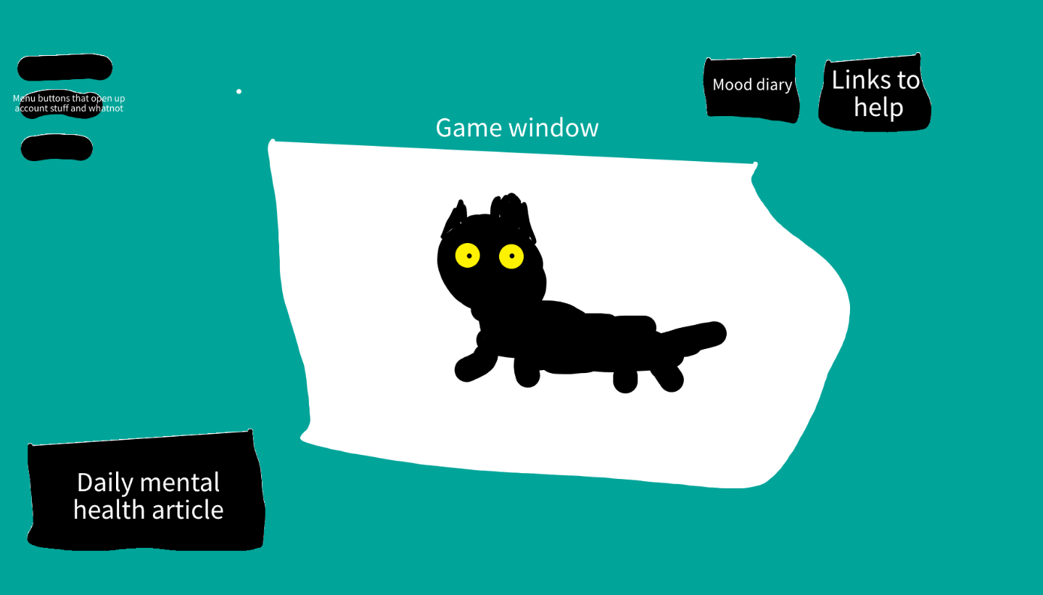

We want more advanced designs for each part. Mainly the buttons on the screens, or if you have any other designs to share that is okay too.